Norwich District Curling Club (NDCC), like many others, could not have imagined the impact of the pandemic on our community and around the world.
In 2019 it became apparent that NDCC needed to look into replacing its club roof. Leading up to our pot pie fundraiser we experienced a large amount of rain and a lot of leaks. The board of directors looked into different options in order to fix this problem and all options were slightly out of our budget so we applied for a grant from Farm Credit Canada (FCC). To our amazement FCC generously granted $20,000 to help with our roof project. A plan was set in motion to replace our flat roof with a pitched roof. However even with the grant we would still have a large sum to cover. This meant our fundraising efforts would be more important than ever. We planned for one of our biggest fundraisers our annual banquet and auction to take place in April 2020.
Unfortunately along came 2020 throwing a very big curve ball in our plans. The world shuts down along with our fundraiser and construction for our new roof. We face delay after delay and a great uncertainty about the 2020-21 season. Fall 2020 arrives and the board had to make the hard decision to not go through with the 2020-21 curling season. We were able to host multiple fundraisers during this time but with no curling season it mostly covered our overhead costs. Thankfully in 2021 things started to look up! Restrictions eased and we were able to move forward with our roof repair.
Along comes another hiccup in our plans. Like most things during COVID-19 the cost of changing our roof to a pitched roof has gone up exponentially due to the increase in lumber cost. Now what? The board of directors now had to adapt once again to make a new plan for the roof. They decide to replace and repair the flat roof instead of the original idea of a pitched roof. Thankfully FCC was willing to work with us with these changes to our roof project. With the FCC funding and our regular curling season reinstated we were on our way to a new roof.
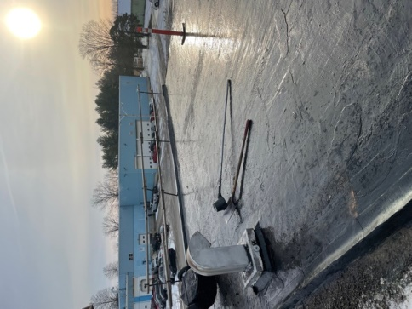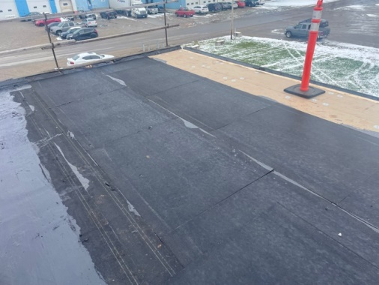
Finally in Dec 2021 we were able to have our roof fixed and replaced. We are now leak free and couldn’t be happier with our partnership with FCC on this project.

